

Alexander Bretoi, Sara Iqbal, Kevin Ou, Jamia Russell

Northwestern University

MSDS 475: Project Management

Project Risk

July 21st, 2024

**FPD DM Project Risk**

**Risk Assessment Matrix**

| **Risk Event** | **Likelihood** | **Impact** | **DetectionDifficulty** | **Risk Rating (Likelihood x Impact)** | **When** |
| --- | --- | --- | --- | --- | --- |
| (R1) Receiving unclean data with low data integrity and missing elements | 4 | 3 | 2 | 12 | 1.3: Source/Cleanse data |
| (R2) Requiring additional resources to meet schedule due to other duties and lack of appropriate skills/experience | 2 | 4 | 3 | 8 | 1.4: Develop analytics models |
| 1.5: Construct/Modify dashboard |
| 1.6: Test dashboard |
| (R3) Define/socialize/accept performance metrics | 3 | 4 | 3 | 12 | 1.6: Test dashboard |
| 1.8: Deploy dashboard |
| (R4) Scope creep | 2 | 3 | 2 | 6 | 1.4: Develop analytics models |
| 1.5: Construct/Modify dashboard |
| (R5) Going over project duration | 4 | 3 | 2 | 12 | 1.4: Develop analytics models |
| 1.5: Construct/Modify dashboard |
| 1.6: Test dashboard |

**1. (R1) Receiving unclean data with low data integrity and missing elements**

* Likelihood: 4 (Likely) - Based on previous experience, it is highly likely that some data quality issues will arise during the data migration and integration phases of the comprehensive information/metrics dashboard implementation.
* Impact: 3 (Moderate) - Unclean data can severely impact the accuracy of reporting, analytics, and decision-making, potentially leading to significant operational challenges.
* Detection Difficulty: 2 (Fairly Low) - While data cleansing can be time-consuming, well-established techniques and tools are available, making this risk relatively easy to mitigate.
* When: 1.3 (Source/Cleanse data) - Data quality issues related to unclean data, low integrity, and missing elements are most likely to surface and require attention during the initial data sourcing and cleansing phase.

**2. (R2) Requiring additional resources to meet schedule due to other duties and lack of appropriate skills/experience**

* Likelihood: 2 (Fairly Unlikely) - While it is possible, it is relatively unlikely that the project will face significant resource constraints due to proper planning and resource allocation.
* Impact: 4 (High) - Resource constraints may cause minor delays or inefficiencies, but can be managed with proper contingency planning.
* Detection Difficulty: 3 (Moderate) - Acquiring additional resources with the right skills and experience can be moderately challenging, but achievable with proper planning and budgeting.
* When: 1.4 (Develop analytics models)/1.5 (Construct/Modify dashboard)/1.6 (Test dashboard) - Resource constraints may become more apparent during the analytics model development phase, dashboard construction, and dashboard testing, when more specialized skills and review are required.

**3. (R3) Define/socialize/accept performance metrics**

* Likelihood: 3 (Moderately Possible) - It is possible that there may be some disagreements or challenges in defining and socializing the performance metrics among stakeholders.
* Impact: 4 (High) - Poorly defined or widely unaccepted performance metrics can significantly impact the effectiveness of the comprehensive information/metrics dashboard implementation and the resulting analytics and reporting.
* Detection Difficulty: 3 (Moderate) - Aligning stakeholder expectations and reaching a consensus on performance metrics can be a moderately complex process.
* When: 1.6 (Test dashboard)/1.8 (Deploy dashboard) - Issues related to defining, socializing, and gaining acceptance of performance metrics may arise during the dashboard testing phase when stakeholders can review the metrics, and also during the final deployment phase when the metrics are presented to the broader user community.

**4. (R4) Scope creep**·

* Likelihood: 2 (Possible) - It is possible for scope creep to occur, as stakeholders may request additional features or changes during the project lifecycle.
* Impact: 3 (Moderate) - Scope creep can lead to schedule delays, increased costs, and resource constraints, but can be managed with proper change control processes.
* Detection Difficulty: 2 (Fairly Low) - Managing scope creep requires effective communication, stakeholder alignment, and a robust change control process, which can be somewhat challenging.
* When: 1.4 (Develop analytics models)/1.5 (Construct/Modify dashboard) - Scope creep is a risk that may materialize during the analytics model development and dashboard construction/modification phases, as stakeholders provide feedback and potentially request additional features or changes beyond the initial scope.

**5. (R5) Going over project duration**

* Likelihood: 4 (Likely) - Given the complexity of the project, involving multiple stakeholders, tight budget constraints, and the integration of new technologies like cloud-based AI tools, it is likely that the project may encounter delays and go over the planned duration.
* Impact: 3 (Moderate) - Exceeding the project duration can have moderate consequences, potentially leading to increased costs, missed deadlines, and dissatisfied stakeholders, which could jeopardize the successful completion of the project.
* Detection Difficulty: 2 (Fairly Low) - While managing project timelines can be challenging, there are established techniques and tools available to mitigate this risk, such as resource allocation, schedule adjustments, and effective communication with stakeholders.
* When: 1.4 (Develop analytics models)/1.5 (Construct/Modify dashboard)/1.6 (Test dashboard) - The risk of going over the project duration may become more apparent during the development of analytics models, dashboard construction, and testing phases, where delays or unforeseen issues could potentially impact the project timeline.

**Risk Severity Matrix**

| **Likelihood** |  | **1** | **2** | **3** | **4** | **5** |
| --- | --- | --- | --- | --- | --- | --- |
| **5** |  |  |  |  |  |
| **4** |  |  | (R1) Receiving unclean data with low data integrity and missing elements  (R5) Going over project duration |  |  |
|
| **3** |  |  |  | (R3) Define/socialize/accept performance metrics |  |
| **2** |  |  | (R4) Scope creep | (R2) Requiring additional resources to meet schedule due to other duties and lack of appropriate skills/experience |  |
| **1** |  |  |  |  |  |
|  |  | **Very low** | **Low** | **Moderate** | **High** | **Very high** |
|  |  | **Impact** | | | | |

| **Very Low:** Negligible risks in this category are highly unlikely to materialize and would have minimal consequences if they did occur. |
| --- |
| **Low:** While possible, risks at this level would cause relatively minor issues to the project plan. |
| **Moderate:** Moderate risks with a moderate chance of occurrence that could generate a considerable amount of project issues. |
| **High:** Highly likely risks that will undoubtedly impact and significantly disrupt the project if they arise. |
| **Very High:** Catastrophic risks in this category are near-inevitable occurrences that would likely derail the entire project if not properly mitigated. |

The placement of each Risk Event in the Risk Severity Matrix (RSM) is based on the Likelihood and Impact ratings from the Risk Assessment Matrix (RAM).

**1. (R1) Receiving unclean data with low data integrity and missing elements** is placed in the top-middle quadrant (Likelihood: 4, Impact: 3) as it is considered a "High" risk due to its likely occurrence and potential for significant impact on data quality and reporting.

**2. (R2) Requiring additional resources to meet schedule due to other duties and lack of appropriate skills/experience** is placed in the low-right quadrant (Likelihood: 2, Impact: 4) as it is considered a "Moderate" risk, with a relatively unlikely occurrence, but with high potential impact on project timelines.

**3. (R3) Define/socialize/accept performance metrics** is placed in the middle-right quadrant (Likelihood: 3, Impact: 4) as it is considered a "Moderate" risk, with a possible occurrence and potential for high impact on the effectiveness of the comprehensive information/metrics dashboard implementation.

**4. (R4) Scope creep** is placed in the low-middle quadrant (Likelihood: 2, Impact: 3) as it is considered a "Low-Moderate" risk, with a possible occurrence and moderate impact on project schedules and costs.

**5. (R5) Going over project duration** is placed in the top-middle quadrant(Likelihood: 4, Impact: 3)as it is considered a "High" risk due to its near-certainty of occurrence and potentially catastrophic impact on the project.

**Risk Response Matrix**

| **Risk Event** | **Response** | **Contingency Plan** | **Trigger** | **Responsible Party** | **Cost Estimate** |
| --- | --- | --- | --- | --- | --- |
| (R1) Receiving unclean data with low data integrity and missing elements | Accept | Add additional resources to cleanse data, and develop data protocols/quality standards/quality checks | Data is of lower quality than expected | ERP Analyst, Database Analyst | $10,000 - $20,000 |
| (R2) Requiring additional resources to meet schedule due to other duties and lack of appropriate skills/experience | Accept | Add additional resources to help with duties | Current resources require more time overall to complete everything; Persistent and consistent overtime accrued | Project Manager | $30,000 - $50,000 |
| (R3) Define/socialize/accept performance metrics | Mitigate: meetings with stakeholders to validate metrics | Gather feedback from stakeholders to implement changes of the dashboard | Widespread user criticism | Executive Oversight Committee (EOC) | $5,000 - $10,000 |
| (R4) Scope creep | Mitigate: meetings with stakeholders redefine scope | Redefine stakeholder expectations | Stakeholders, clients, or users start requesting more features not listed in proposal | Project Manager | $20,000 - $40,000 |
| (R5) Going over project duration | Avoid | Add more resources, either funds or people; Reconstruct project timeline | Project is consistently performing behind on schedule | Project Manager, Project Sponsor (CFO) | $50,000 - $100,000 |

**1. (R1) Receiving unclean data with low data integrity and missing elements**

* Response: Accept - The project team acknowledges the likelihood of this risk occurring and plans to address it through contingency measures.
* Contingency Plan: Add additional resources to cleanse data - If data quality issues arise, the plan is to allocate additional resources (personnel or tools) to cleanse data and improve the data integrity.
* Trigger: Data is of lower quality than expected - The contingency plan will be triggered if the data quality falls below the expected standards, as determined by the project team or stakeholders.
* Responsible Party: ERP Analyst/ Database Analyst - The ERP Analyst and Database Analyst will be responsible for monitoring data quality, identifying issues, and implementing the data cleansing efforts as needed.
* Cost Estimate: $10,000 - $20,000
  + This cost range accounts for the additional resources and effort required to cleanse and fix the unclean data.
  + It may involve hiring temporary data analysts or bringing in external data cleansing services.
  + The lower end of the range ($10,000) assumes a moderate amount of data cleaning is required, while the higher end ($20,000) accounts for more extensive data issues.

**2. (R2) Requiring additional resources to meet schedule due to other duties and lack of appropriate skills/experience**

* Response: Accept - The project team acknowledges the possibility of resource constraints and plans to address them through contingency measures.
* Contingency Plan: Add additional resources to help with duties - If resource constraints arise, the plan is to acquire additional resources (personnel or consultants) to supplement the existing team and ensure timely project completion.
* Trigger: Current resources require more time overall to complete everything; Persistent and consistent overtime accrued - The contingency plan will be triggered if the existing resources are consistently struggling to meet deadlines or working excessive overtime.
* Responsible Party: Project Manager - The Project Manager will be responsible for monitoring resource utilization, identifying constraints, and coordinating the acquisition of additional resources as needed.
* Cost Estimate: $30,000 - $50,000
  + This cost range covers the expenses associated with hiring additional personnel or contracting external resources to supplement the existing team.
  + The lower end ($30,000) may include hiring a temporary resource or consultant for a shorter duration.
  + The higher end ($50,000) may involve bringing on multiple resources or more specialized expertise for a longer period.

**3. (R3) Define/socialize/accept performance metrics**

* Response: Mitigate - The project team aims to proactively mitigate this risk by involving stakeholders in the performance metric definition process.
* Contingency Plan: Gather feedback from stakeholders to implement changes to the dashboard - If widespread criticism or dissatisfaction with the performance metrics arises, the plan is to gather stakeholder feedback and make necessary adjustments to the dashboard or reporting.
* Trigger: Widespread user criticism - The contingency plan will be triggered if there is significant negative feedback or lack of acceptance from stakeholders and the project team regarding the performance metrics.
* Responsible Party: Executive Oversight Committee (EOC) - The Executive Oversight Committee will be responsible for facilitating stakeholder meetings, gathering feedback, and overseeing any necessary changes to the performance metrics or dashboard.
* Cost Estimate: $5,000 - $10,000
  + This relatively lower cost range ($5,000) is associated with the effort required to hold meetings, gather feedback, and align stakeholders on the performance metrics.
  + It may include costs for organizing workshops, facilitating discussions, and implementing minor adjustments to dashboards or reporting.
  + The upper end ($10,000) accounts for more extensive stakeholder engagement and potential design changes.

**4. (R4) Scope creep**

* Response: Mitigate - The project team aims to mitigate scope creep through regular stakeholder meetings and effective change control processes.
* Contingency Plan: Redefine stakeholder expectations - If scope creep occurs, the plan is to reassess and redefine the project scope, expectations, and timelines in consultation with stakeholders.
* Trigger: Stakeholders, clients, or users start requesting more features not listed in the proposal - The contingency plan will be triggered if stakeholders begin requesting additional features or changes beyond the initially agreed-upon scope.
* Responsible Party: Project Manager - The Project Manager will be responsible for facilitating stakeholder meetings, managing change requests, and overseeing the scope redefinition process as needed.
* Cost Estimate: $20,000 - $40,000
  + Scope creep can have significant cost implications as it may require additional resources, extended timelines, and rework.
  + The lower end ($20,000) may cover the costs of managing minor scope changes and realigning expectations.
  + The higher end ($40,000) accounts for more substantial scope expansions, which may require additional development, testing, and integration efforts.

**5. (R5) Going over project duration**

* Response: Avoid - The project team aims to avoid this risk by proactively managing the project schedule and taking preventive measures.
* Contingency Plan: Add more resources, either funds or people; Reconstruct project timeline - If the project consistently falls behind schedule, the plan is to either allocate additional resources (funds or personnel), or reconstruct the project timeline to ensure timely completion.
* Trigger: Project is consistently performing behind schedule - The contingency plan will be triggered if the project consistently fails to meet milestones or deadlines, indicating a high risk of running out of time.
* Responsible Party: Project Manager, Project Sponsor (CFO) - The Project Manager and Project Sponsor (CFO) will be responsible for monitoring project progress, identifying schedule slippages, and implementing the contingency plan by allocating additional resources or adjusting the timeline as needed.
* Cost Estimate: $50,000 - $100,000
  + This cost range represents the most significant financial impact, as it addresses the risk of project delays and potential failure.
  + The lower end ($50,000) may involve adding limited resources or making minor timeline adjustments.

**Change Control Process**

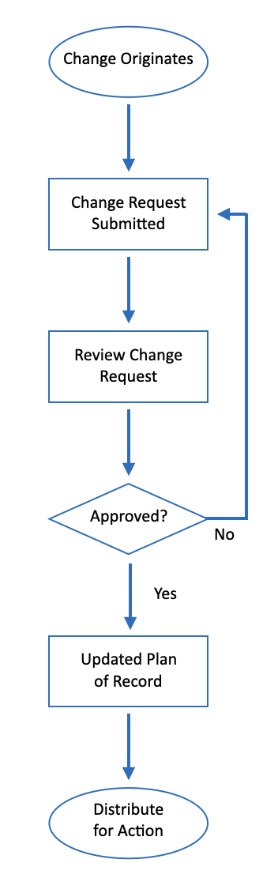

Based on the Change Control Process flow and the provided Risk Assessment Matrix (RAM), Risk Severity Matrix (RSM), and Risk Response Matrix (RRM), the following steps are required across the change control process:

**1. Change Originates:** A change request can originate from various sources, such as stakeholders, team members, or external factors. This step initiates the change control process.

**2. Change Request Submitted:** The originator of the change formally submits a change request form, detailing the proposed change, its rationale, and potential impacts. This form should include information from the Risk Assessment Matrix (RAM), such as the risk event, likelihood, impact, difficulty, and when the risk may occur.

**3. Review Change Request:** The change request is reviewed and evaluated by the appropriate parties, which may include the Project Manager, Executive Oversight Committee (EOC), or other relevant stakeholders. During this review, the Risk Severity Matrix (RSM) can be consulted to assess the likelihood and impact of the proposed change on the project.

**4. Approved?:** Based on the review, a decision is made whether to approve or reject the change request. If the change is deemed too risky or disruptive to the project, it may be disapproved or deferred.

**5. Update Plan of Record:** If the change request is approved, the project plan, including the Risk Response Matrix (RRM), is updated to incorporate the approved change. The RRM outlines the response strategies, contingency plans, triggers, and responsible parties for addressing potential risks associated with the change.

**6. Distribute for Action:** Once the project plan is updated, the approved change and any necessary adjustments or mitigation strategies are communicated to the relevant parties, such as the Project Manager, IT Manager, ERP Application Analyst, Database Analyst, Supply Chain Analyst, and/or Sales Operations Analyst, depending on the nature of the change.

Throughout the change control process, it is essential to maintain clear documentation, communicate effectively with all stakeholders, and continuously monitor and update the risk management matrices (RAM, RSM, and RRM) to ensure that potential risks are identified, assessed, and mitigated effectively.

**Change Control Documents**

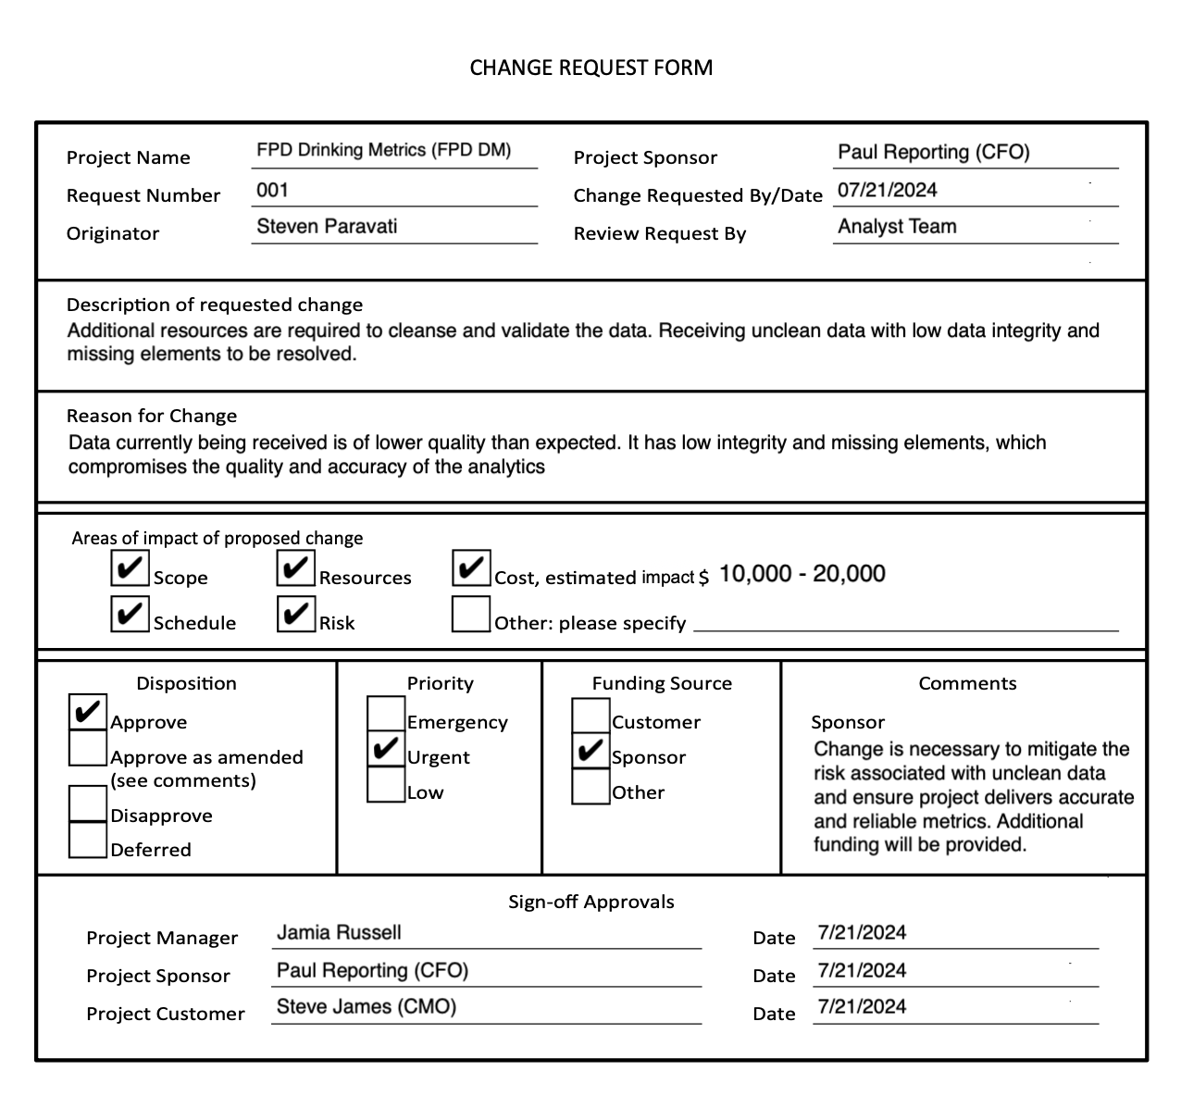

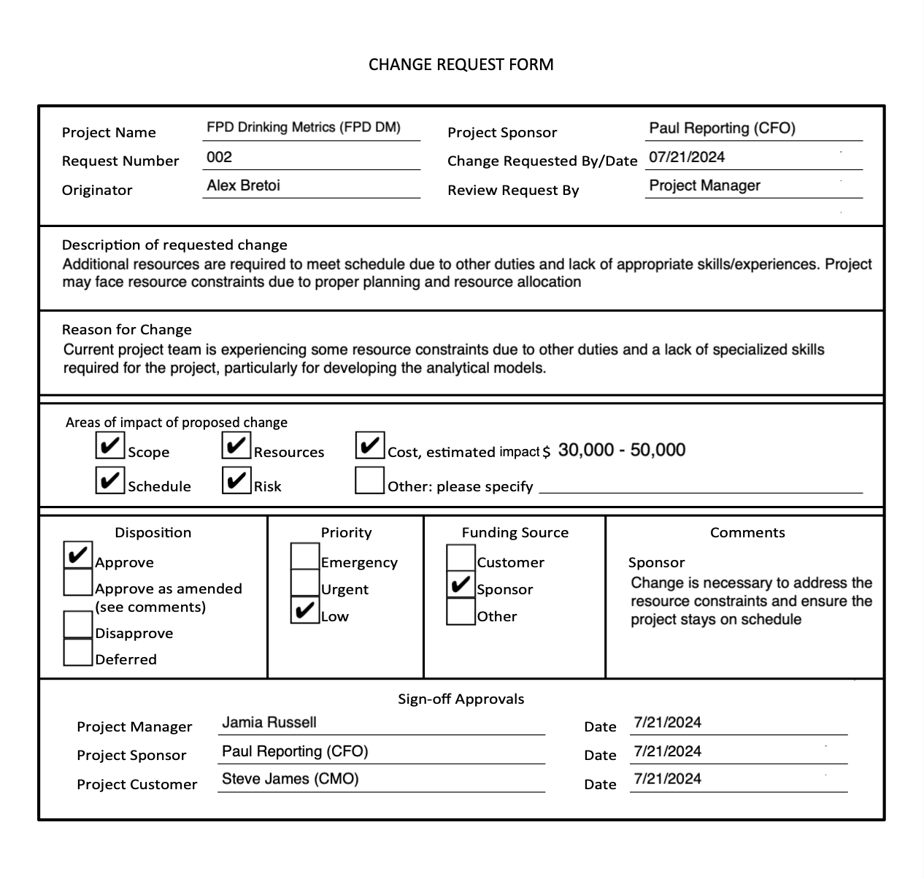

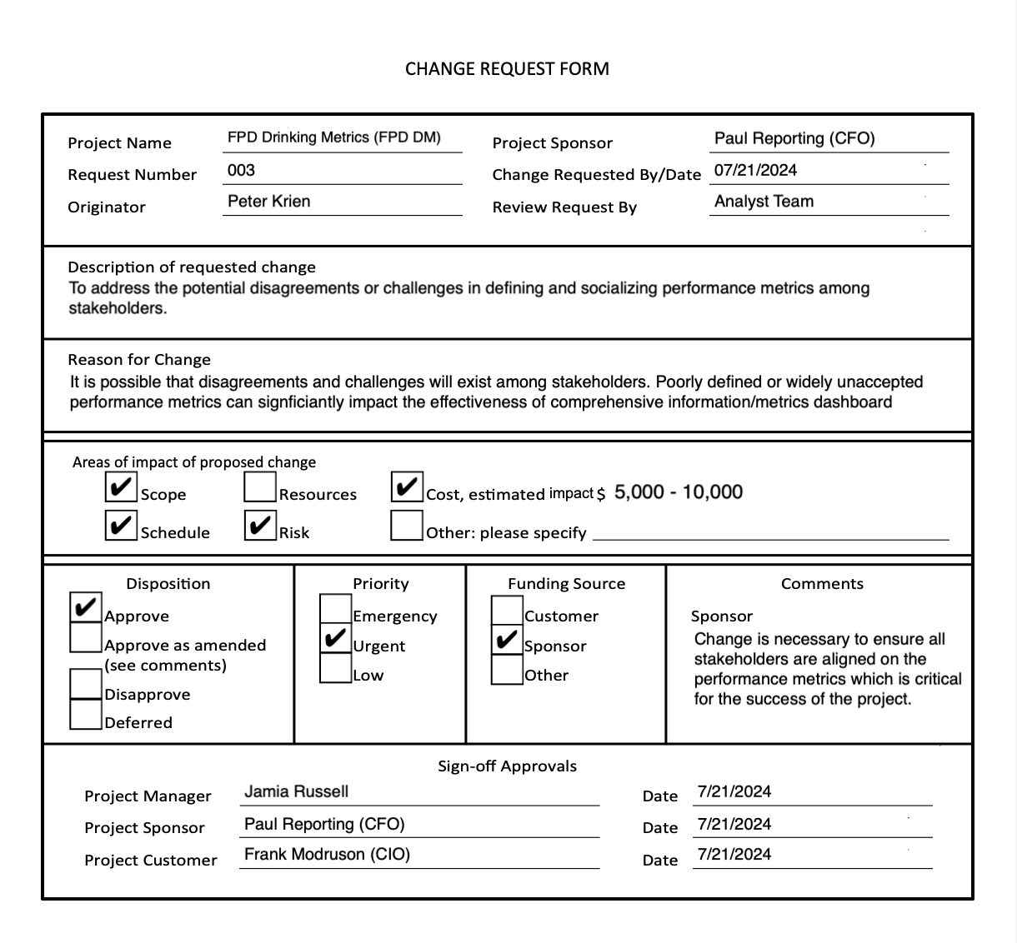

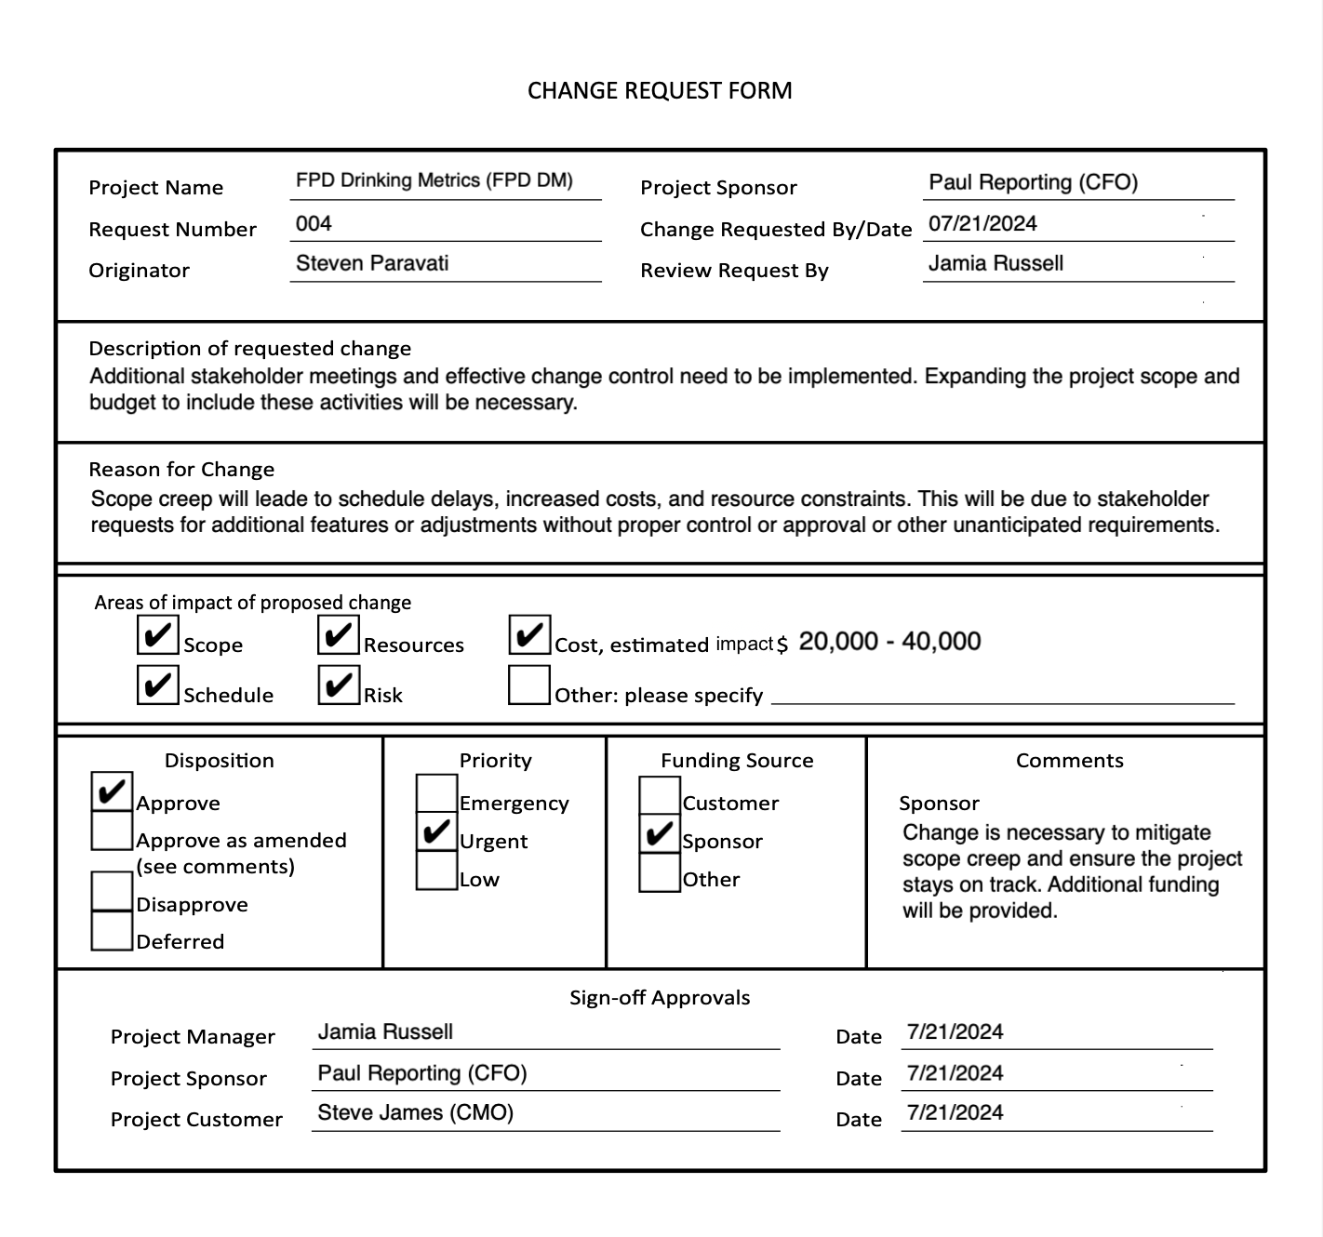

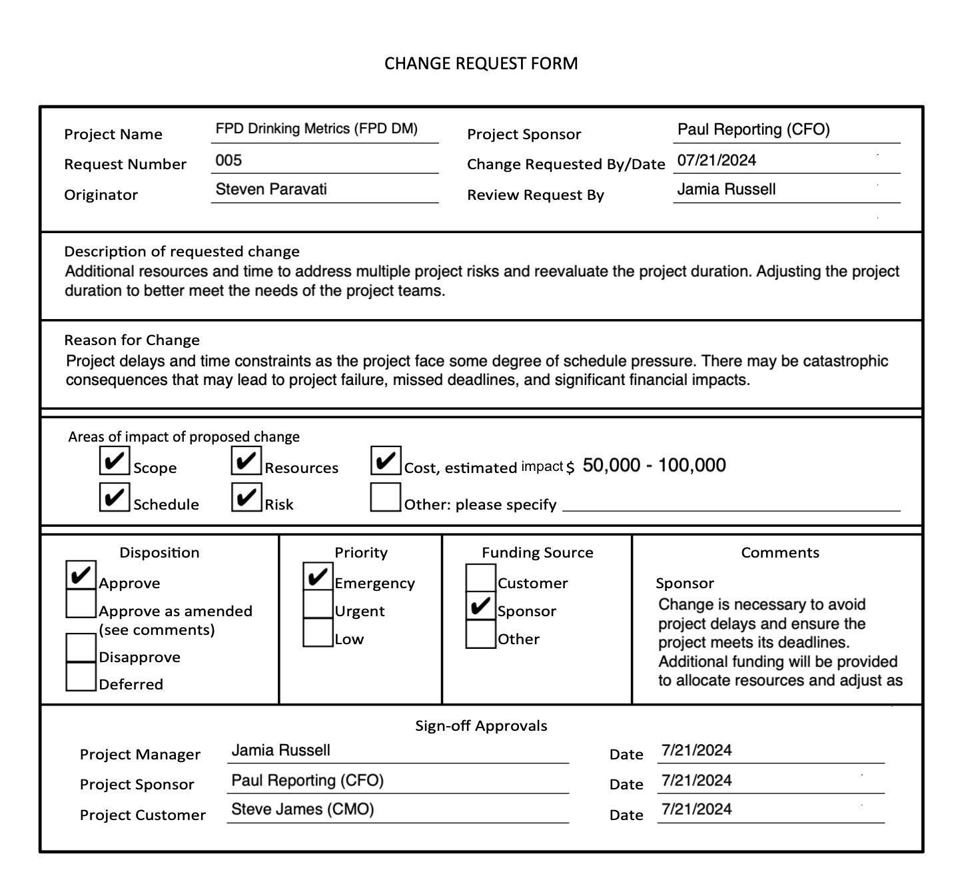

**Overall Risk Assessment**

The FPD Drinking Metrics (FPD DM) project represents a critical initiative for FPD Beverage Company, aiming to develop a comprehensive information and metrics dashboard to support data-driven decision-making in sales and operations. However, as with any complex undertaking, the project faces several potential risks that necessitate meticulous assessment and effective management strategies to ensure successful execution.

The risk of (R1) Receiving unclean data with low data integrity and missing elements is rated as highly likely (4) with a moderate impact (3), reflecting the potential for severe data quality issues that could undermine the accuracy and reliability of the dashboard's reporting and analytics capabilities. This risk is expected to manifest during the crucial data sourcing and cleansing phase (WBS Task 1.3), which lays the foundation for the entire project. The Risk Severity Matrix (RSM) further underscores the criticality of this “High” risk, placing it in the top-middle quadrant, denoting a risk that could severely compromise the accuracy and reliability of the dashboard's reporting and analytics capabilities. The contingency plan outlined in the RRM involves allocating additional resources, overseen by the ERP and Database Analysts, to cleanse and enhance the data quality. The cost estimate of $10,000 to $20,000 for this contingency plan is appropriate, as it accounts for the potential need to hire temporary data analysts or bring in external data cleansing services. The lower end of $10,000 assumes a moderate level of data cleaning is required, while the higher end of $20,000 accounts for more extensive data quality issues that may necessitate a greater investment in resources and effort.

Equally concerning is the risk of (R5) Going over the project duration, which shares the same likelihood (4 - Likely) and impact (3 - Moderate) ratings as (R1), similarly positioning this “High” risk in the top-middle quadrant of the RSM. Given the project's complexity, involving multiple stakeholders, tight budgets, and the integration of new technologies, it is understandable that adhering to the planned timeline could be challenging. Failure to meet deadlines could result in escalating costs, stakeholder dissatisfaction, and potentially jeopardize the successful completion of the project. To mitigate this risk, the RRM proposes a significant contingency plan involving the addition of resources or adjusting the project timeline, overseen by the Project Manager and Project Sponsor (CFO). The estimated cost range of $50,000 to $100,000 for this contingency plan is justified, as it represents the most significant financial impact and addresses the risk of project delays and potential failure. The lower end of $50,000 may involve adding limited resources or making minor timeline adjustments, while the higher end of $100,000 accounts for more substantial delays and the need for significant resource augmentation or timeline revisions.

The “Moderate” risk of (R3) Define/socialize/accept performance metrics is also noteworthy in the middle-right quadrant of the RSM, rated as moderately possible (3) with a high impact (4). Aligning stakeholder expectations and reaching a consensus on the performance metrics is crucial for the effectiveness of the comprehensive information and metrics dashboard implementation. The proposed mitigation strategy of stakeholder meetings and feedback gathering, led by the Executive Oversight Committee (EOC), with an estimated cost of $5,000 to $10,000, appears reasonable. The lower end of $5,000 accounts for the basic effort required to hold meetings, gather feedback, and align stakeholders on the performance metrics, potentially including costs for organizing workshops and facilitating discussions. The upper end of $10,000 allows for more extensive stakeholder engagement and potential design changes, which may be necessary if significant adjustments to the dashboards or reporting are required based on stakeholder feedback.

While the risks of (R2) Requiring additional resources to meet schedule due to other duties and lack of appropriate skills/experience, and (R4) Scope creep are lower in probability, their potential impacts on project timelines, costs, and resource constraints should not be overlooked.

For “Moderate” risk (R2) Requiring additional resources to meet schedule due to other duties and lack of appropriate skills/experience in the low-right quadrant of the RSM, the RRM outlines an acceptance strategy with a contingency plan to add additional resources to assist with duties, managed by the Project Manager. The cost estimate range of $30,000 to $50,000 is appropriate, as it covers the expenses associated with hiring additional personnel or contracting external resources to supplement the existing team. The lower end of $30,000 may include hiring a temporary resource or consultant for a shorter duration, while the higher end of $50,000 accounts for the need to bring on multiple resources or more specialized expertise for a longer period.

Similarly, for the “Low-Moderate” risk of (R4) Scope creep in the low-middle quadrant of the RSM, the RRM proposes a mitigation strategy involving meetings with stakeholders to redefine the scope and reset expectations, led by the Project Manager. The estimated cost range of $20,000 to $40,000 aligns with the potential impact of scope creep, as it can have significant cost implications due to the need for additional resources, extended timelines, and rework. The lower end of $20,000 may cover the costs of managing minor scope changes and realigning expectations, while the higher end of $40,000 accounts for more substantial scope expansions, which may require additional development, testing, and integration efforts.

Collectively, the identified risks and their associated cost estimates for mitigation and contingency plans highlight the criticality of thorough risk management for the FPD DM project. The total additional cost estimate for these risk response strategies ranges from approximately $5,000, if only the low-end cost estimate of (R3) Define/socialize/accept performance metrics comes to fruition, all the way up to $220,000 across all risk response strategies in the scenario that they all occur at their highest cost estimate, representing a substantial investment in risk mitigation efforts. However, this investment is justified by the strategic importance of the project and the potential financial and operational consequences of project delays, data quality issues, or stakeholder dissatisfaction.